DOI:
Aphids (HEMIPTERA: APHIDIDAE) on PEACH TREES in BULGARIA

Radoslav Andreev*, Pavlin Vasilev

Agricultural University – Plovdiv

*E-mail: rado@au-plovdiv.bg

Abstract
The species complex and infestations of aphids on peach trees (Prunus persica) in Bulgaria were investigated during the period 2013-2017. Eight species from the Aphididae family were found: Green peach aphid (Myzus persicae, Sulzer), Peach-clematis aphid (Myzus varians, Davidson), Black peach aphid (Brachycaudus persicae, Passerini), Peach aphid (Brachycaudus schwartzi, Börner), Almond aphid (Brachycaudus amygdalinus, Schouteden), Mealy peach aphid (Hyalopterus amygdali, Blanchard), Waterlily aphid (Rhopalosiphum nymphaeae, Linnaeus) and Peach trunk aphid (Pterochloroides persicae, Cholodkovsky). Myzus persicae and Peach-clematis aphid Myzus varians were of the greatest importance as pests due to their wide distribution and high population density. The former was more widely spread in South Bulgaria, while the attack of the latter was almost even across the country. The recently reported species Brachycaudus schwartzi is already distributed throughout the country. The species has a higher density in the southern part of the country, in regions where peach trees are grown. Hyalopterus amygdali also occurs mainly in the southern part of the country and cоuld be a dangerous pest in infested orchards.
Keywords: peach aphid, Myzus, Brachycaudus, distribution, infestation.

INTRODUCTION
Peach orchards in our country have grown significantly in recent years. Most of them are planted in the southern part of the country, but there are plantings in the northern areas too. Most important pest on peach are Oriental fruit moth and Peach twig borer, but orchards annually are infested by aphids. Three of the species are also considered to be with great economic significance. These are Mealy peach aphid (Hyalopterus amygdali), Green peach aphid (Myzus persicae) and Peach-clematis aphid (Myzodes varians) (Lecheva et al., 2006; Stancheva et al., 2008).
Detailed studies on aphids on peaches in our country have been conducted more than 20 years ago (Grigorov et al., 2004). Since then significant changes in the structure and size of the orchards as well as the methods for control of this pests took place. The aim of the present study was to establish species composition, distribution, and rate of infestation of aphids on peach in Bulgaria.

MATERIALS AND METHODS
The present study was conducted by visual surveys in the years 2013–2017. Observations have been conducted twice a year in May-June and July-August. In 2013 the data were collected only in Plovdiv district. In the following two years different areas of 126 municipalities across all 28 districts of Bulgaria have been surveyed – in 2014 the southern part of the country and in 2015 the northern part. The number of surveyed locations depended on the area of the respective district. Single observations were conducted over the next two years: 2016-2017. In each of the observed orchards, a minimum of 200 shoots were examined placed on 10-20 trees, randomly located in the area.
The percentage of infested shoots for each species of aphids was established. For Peach trunk aphid the percentage of infested trees was determined. The data was then converted to the five-grade scale, developed by Mikhailova et al. (1982), where the grade 0 indicated no infested shoots; grade 1 – less than 5% infested shoots; grade 2 – between 5 and 15% of infested shoots; grade 3 – between 15 and 50% of infested shoots and grade 4 – more than 50% of infested shoots. The maps presented in "Results and Discussion" show only where the aphids are found.
When the aphid species could not be identified visually by the colour of individuals in a colony or by a view of damage, the microscope slides were prepared according to the method of Martin (1983).
The keys of Mordvilko (1948), Shaposh-nikov (1964), Blackman and Eastop (1984; 2000) and Leclant (2000) were employed for identification.

RESULTS AND DISCUSSION
Eight aphid species (Hemiptera: Aphididae) were found feeding on peach (Prunus persica) in Bulgaria: Green peach aphid (Myzus persicae, Sulzer), Peach-clematis aphid (Myzus varians, Davidson), Black peach aphid (Brachycaudus persicae, Passerini), Peach aphid (Brachycaudus schwartzi, Börner), Almond aphid (Brachycaudus amygdalinus, Schouteden), Mealy peach aphid (Hyalopterus amygdali, Blanchard), Waterlily aphid (Rhopalosiphum nymphaeae, Linnaeus) and Peach trunk aphid (Pterochloroides persicae, Cholodkovsky).
Myzus persicae (pic.1) is a widespread pest on peach in Bulgaria. The infestation of aphids is significantly stronger in the Southern part of the country (fig. 1), where the species was found in 48 municipalities (from 68 observed). Infested shoots over 15% (grade 3) were found in ten municipalities. The strongest attack was found in the municipalities of Dupnitsa (27.9%), Karlovo (26.5%) and Chernoochene (25.8%). In the Northern part of Bulgaria, Green peach aphid was found only in fifteen municipalities (from 58 observed) scattered throughout the territory. Everywhere infestation was up to 5%. In two districts – Razgrad and Targovishte the aphid was not detected.
Myzus varians (pic. 2) is a widespread species of peach in our country too. In some areas, its density even exceeds density that of Green peach aphid (fig. 2). In Northern Bulgaria, the aphid was found in the all observed municipalities. The highest infestation (46,5%) was established in municipality Sevlievo. In five other municipalities, the infestation exceeded 15%. In the Southern part of Bulgaria, the aphid was found in 45 municipalities. In 12 municipalities the infestation exceeded 15% – the strongest in Karlovo (41.0%) and Peshtera (37.8%). The spread and infestation of the species have been observed over the period 2013–1015. In the next two years, characterized was with dry and hot summer, infestation in the number of areas was significantly reduced.
The species Brachycaudus schwartzi (pic. 3) is relatively new to our country – it was announced in 2015 by this author's team (Vasilev & Andreev, 2015). The aphids formed colonies on peaches in the summer, so observations were conducted in July and August. The study showed that the species is present in all regions of the country, although there is a more limited spread than M. persicae and M. varians (fig. 3). In northern Bulgaria, it was found only in 13 of the 58 municipalities. In the southern part of the country, the species are with much wider distribution and is found in 46 municipalities, probably because there are the main areas where peaches are grown. In nine districts the aphid was not found - Vidin, Vratsa, Shumen, Lovech, Targovishte, Pernik, Kardzhali, Haskovo, and Yambol.
The species is most common in the districts of Blagoevgrad, Plovdiv and Sliven, where it was established in all observed municipalities. The aphids are widespread in the districts of Bourgas and Stara Zagora too. The infestations remained localized on individual trees and nowhere exceed 5%. This is why the species is not of great economic significance so far, but its appearance in the period of ripening would make it more difficult to control in the case of high infestation.
Hyalopterus amygdali (pic. 4) is with a significantly limited distribution in Bulgaria, compared to the previous three species (fig. 4). The species was found in twelve of the observed districts – six in Northern part and six in the Southern part of Bulgaria.
The aphid was most widespread in the districts of Blagoevgrad and Haskovo, where the species was found in three municipalities. The highest infestation of shoots was registered in the municipalities of Krumovgrad (20.7%) and Lyubimets (18.2%). In half of the inhabited regions, the infestation is over 5%.
Brachycaudus persicae (pic. 4) is a relatively rare species on peach in our country (fig. 5). The aphid was found by this host only in six municipalities in four of the districts – Burgas, Kardzhali, Plovdiv (South Bulgaria) and Targovishte (North Bulgaria).
Only in two municipalities Momchilgrad and Plovdiv the infestation exceeded 5%, while in Plovdiv have been recorded the highest value of 11,1%. In the other regions, the infestation did not exceed 2%. The remaining three species of aphids found on the peach tree in Bulgaria were with low distribution and density (fig. 6). The species Brachycaudus amygdalinus was found only in the municipality of Vratsa with an infestation of 0.8%. The Waterlily aphid Rhopalosiphum nymphaeae was found only in the district of Plovdiv – the municipalities of Plovdiv and Hissar. The Peach trunk aphid Pterochloroides persicae was established only on the trunk of single trees in two regions of the municipality of Plovdiv and one orchard of the municipality of Harmanli.

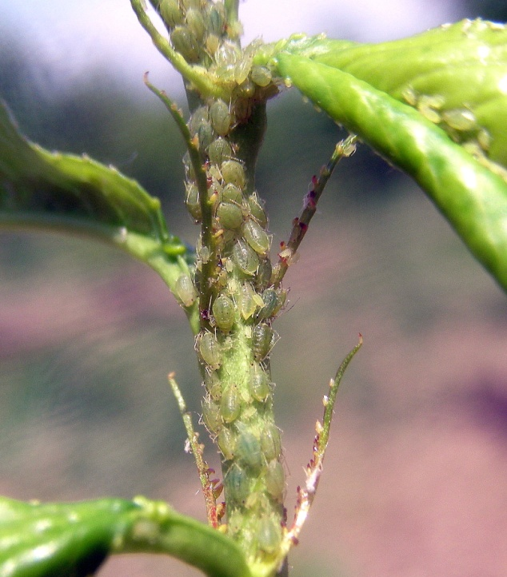 a | 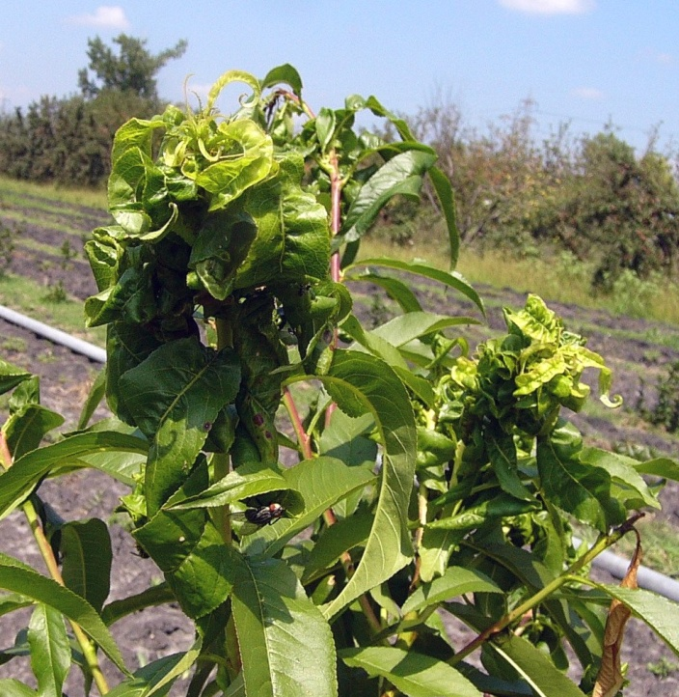 b

Pict. 1. Myzus persicae – colony of apterous forms (a) and damage (b)

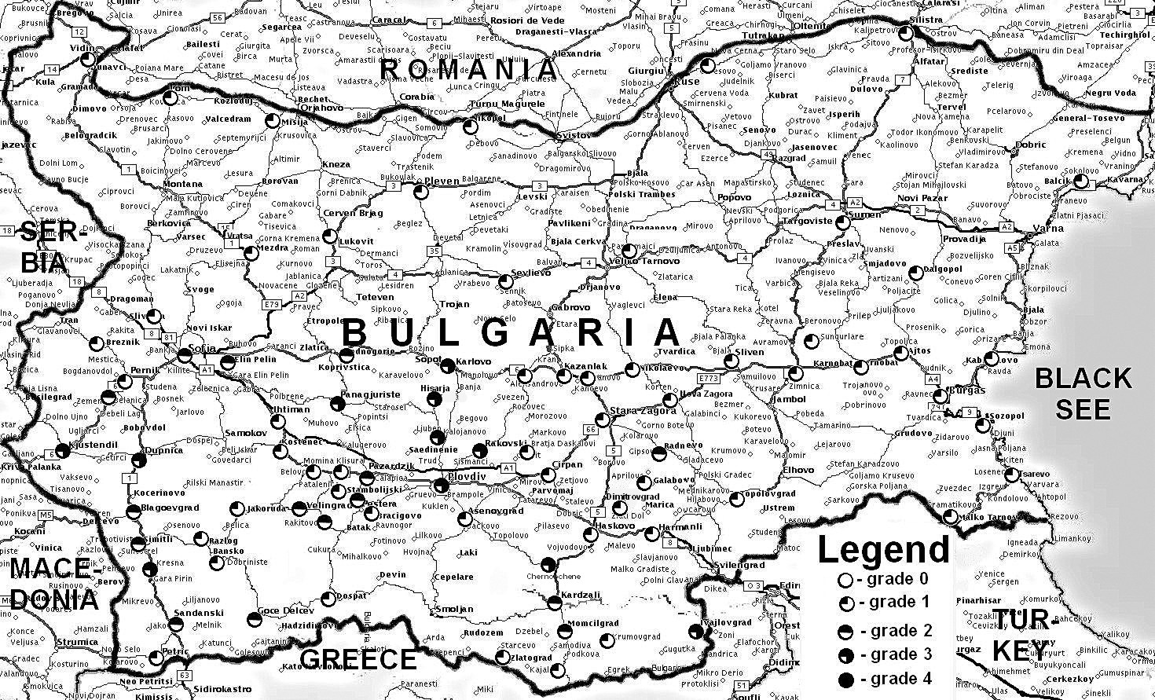

Fig. 1. Distribution and infestation of Myzus persicae on peach in Bulgaria during 2013/2017

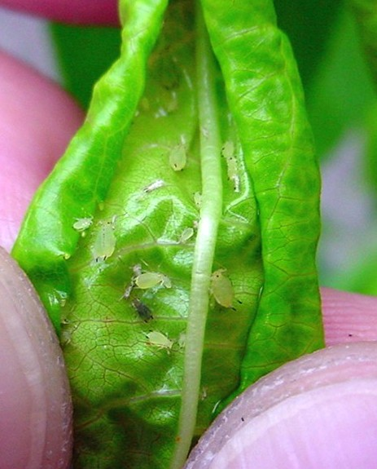 a | 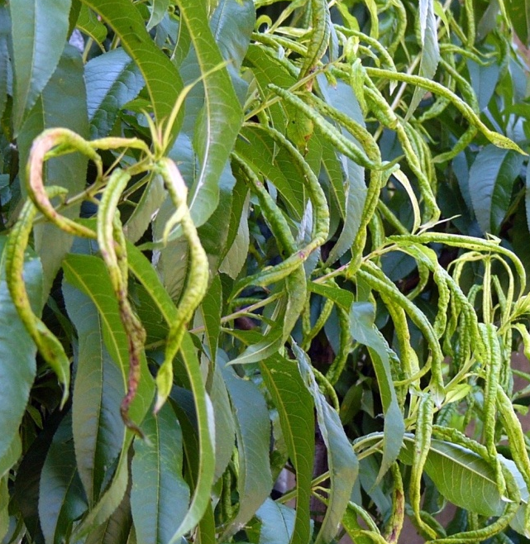 b

Pict. 2. Myzus varians – colony of apterous forms (a) and damage (b)

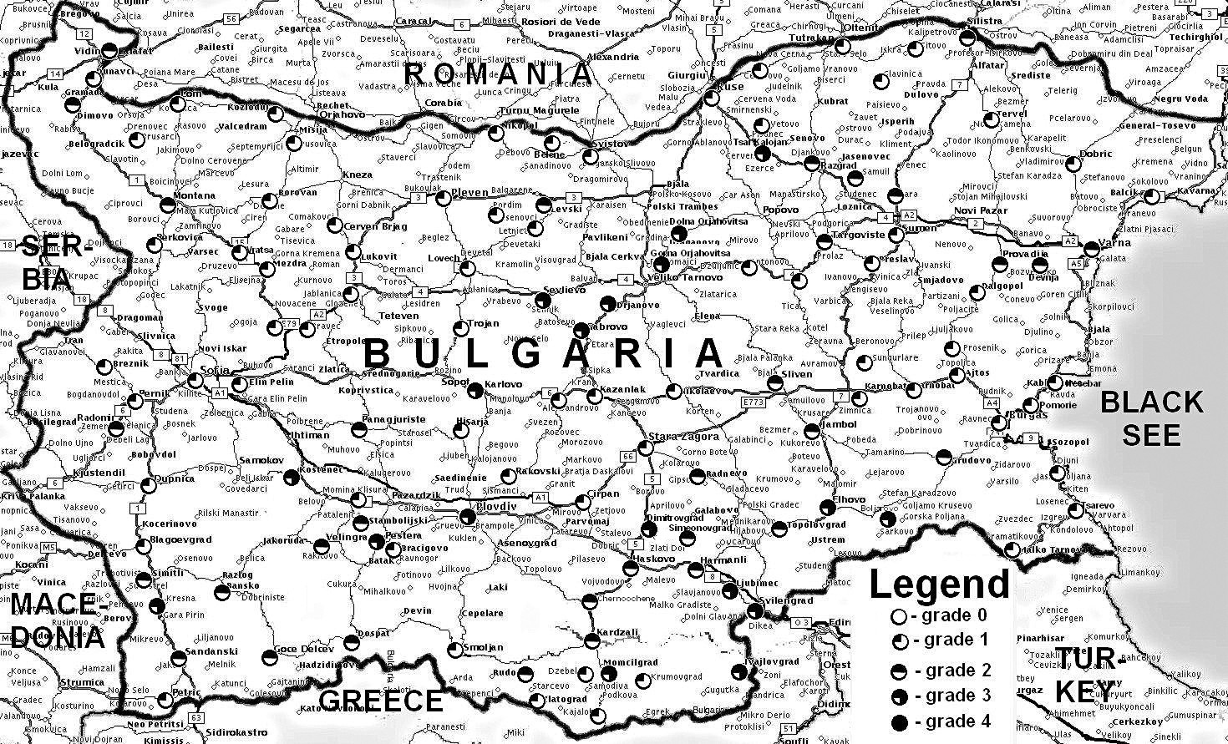

Fig. 2. Distribution and infestation of Myzus varians on peach in Bulgaria during 2013/2017

Fig. 3

Pict. 3

Fig. 4

Pict. 4

CONCLUSIONS
Eight aphid species were found on peach in Bulgaria: Myzus persicae, Myzus varians, Brachycaudus persicae, Brachycaudus schwartzi, Brachycaudus amygdalinus, Hyalopterus amygdali, Rhopalosiphum nymphaeae and Pterochloroides persicae.
The most dangerous for orchards are species of the genus Myzus. They are widespread and caused strong infestations on the shoots.
The species Brachycaudus schwartzi is relatively new to Bulgaria but is already spread throughout the country, mostly in the southern regions where large orchards with peaches are grown. The infestations are relatively weak, and so far it does not pose a serious threat to orchards.
Hyalopterus amygdali is with a limited distribution, but where the aphid occurs causes significant infestation and can become a dangerous local pest.
Brachycaudus persicae, Brachycaudus amygdalinus, Rhopalosiphum nymphaeae and Pterochloroides persicae are the pests with low importance on peaches in our country due to their limited distribution and relatively weak infestations.

REFERENCES
Vasilev, P., R. Andreev, 2015. Distribution and population dynamics of Brachycaudus schwartzi Borner and Brachycaudus prunicola Кaltenbach (Hemiptera: Aphididae) on stone fruits in Southern Bulgaria. Agricultural sciences, VII (17), 119-124.
Grigorov, S., D. Tashev, P. Grigorov, 2004. Aphids (Aphidoidea, Homoptera) from Bulgaria and their control. Academic print at Agricultural University, Plovdiv.

Grigorov, S., 1980. Aphids and their control. Zemizdat, Sofia.
Lecheva, I., P. Petrov, M. Nakova, M. Borovinova, N. Velcheva, S. Simova, E. Staneva, L. Ivanova, V. Taseva, St. Kalinova, P. Nikolov, M. Tsenova, 2006. Good plant protection practices on stone fruits. National Services of Plant Protection at Ministry of Agriculture and Forestry, Sofia.
Mordvilko, A., 1948. Suborder Aphidodea – Aphids. From Insect identification guide of European part of SSSR. OGIZ-SELHOZGIZ, Moscow – Leningrad. 187-226.
Stancheva, J., M. Borovinova, R. Andreev, N. Balevski, St. Kalinova, S. Simova, N. Velcheva. E. Staneva, S. Draganova, V. Arnaudov, K. Kolev, A. Stoev, Z. Rankova, M. Georgieva, 2008. Integrated Pest Management Guide for Orchards. National Services of Plant Protection at Ministry of Agriculture and Forestry, Sofia. 63-80.
Shaposhnikov, G., 1964. Suborder Aphidodea – Aphids. From Insect identification guide of European part of SSSR. Publishing House "Science", Moscow - Leningrad. 489-616.
Blackman, R. L., V. F. Eastop, 2004. Aphids on the World's Crops. An Identification and Information Guide. Chichester, UK: John Wiley.
Leclant, F., 2000. Les Pucerons des plantes cultivees clefs d’identificatin. III – Cultures fruitieres. INRA, Paris, France.
Martin, J. H., 1983. The identification of common aphid pests of tropical agriculture. Tropical Pest. Management. 29: 395-411.

